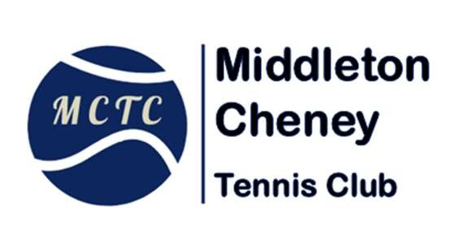
Junior Coaching – August 2026 Green/Yellow Group
Saturday 8th & Saturday 22nd August
Enrolment / Booking Form

Session(s) Booked :- (Delete as appropriate)

~ 8th August 10.00am to 11.00am - Cost £7.00 Club Members or £8.05 Non-Members
~ 22nd August 10.00am to 11.00am Cost £7.00 Club Members or £8.05 Non-Members

Total Amount Due £…………….
Payment can be made via bank transfer to :-
Sort Code 30-11-08, Account No. 16473560 (Account Name Mr Michael R Hodson)

For further information on our coaching programme please contact Michael on
07542 194228 or email: mcytennis@hotmail.co.uk
 | Enrolment Form – August 2026
Name of Junior Player
Date of Birth
Club Member ? | Yes | No
Medical issues
Please tell us about anything you feel the coaches should be aware of, such as asthma etc:
Name of Parent / Guardian
Mobile contact number
Email address

Please note lesson time is different to our regular Saturday lessons– Also time may change depending on numbers.

I am happy for my/our images to be used for club promotional purposes. Don’t forget you can change your mind at any time, or ask for a particular image to be removed or deleted.
I do not wish my/our images to be used for club promotional purposes.
Signature of Parent / Guardian |  | Date:
Our next regular block of coaching will start on 5th September 2026

